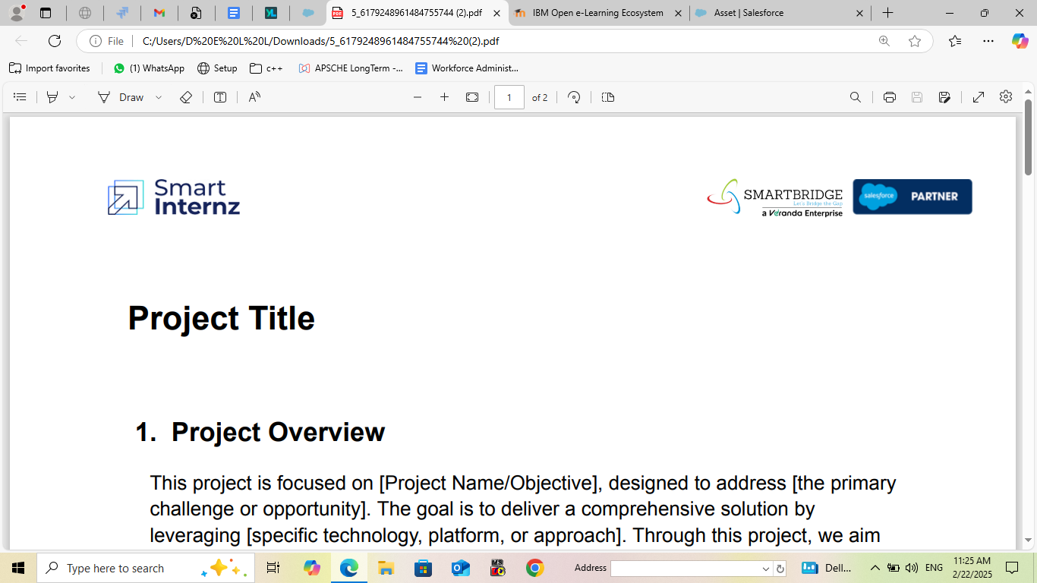

**Workforce Administration solution**

## Sri Vasavi Degree & Pg College

**Team leader :** Kutcharla Bhagya Lakshmi

**Email :** [raorama8536@gmail.com](mailto:raorama8536@gmail.com)

**Team Member :** Kondaveeti Jyothi

**Email :** [kondaveetijyothi733@gmail.com](mailto:kondaveetijyothi733@gmail.com)

**Team Member :** Kasani Pushpavathi

**Email :** [kasanipushpavathi937@gmail.com](mailto:kasanipushpavathi937@gmail.com)

**Team Member :** Peddi S S N V D Deepika

**Email :** [pssnvdeepika@gmail.com](mailto:pssnvdeepika@gmail.com)

**Team Member :** Chode Roji

**Email :** [rojichode@gmail.com](mailto:rojichode@gmail.com)

# **Project Overview** **:**

## Introduction to Salesforce: Overview of Salesforce and its key components -Understanding Salesforce editions and clouds- Exploring the Salesforce platform and its core services.

## 

# **Objectives** **:**

## Configure Salesforce objects, fields, and relationships to support business processes.

## Implement Organization-Wide Defaults (OWD) and Role-Based Access Control to ensure data security.

## Design and deploy page layouts, record types, and permission sets to enhance user experience.

## Develop reports and dashboards to provide real-time insights and support data-driven decision-making.

## Implement Chatter Groups for enhanced collaboration and communication.

## Conduct user training and adoption programs to ensure seamless transition to the new system.

# **Salesforce key features and concepts utilized** **:**

### Creating a developer org.

### Creating custom objects.

### Tabs.

### Lighting app(Workforce administration solution).

### Fields and relationships.

### Owd settings.

### User adoption.

### Import data.

### Profiles.

### Roles.

### Users.

### Page layouts.

### Chatters group.

### Record types.

### Permission sets.

### Reports and Dashboards.

# Detailed steps to solution design :

## Creating custom objects.

### Asset ServicesAsset

### ProjectTask

### Project

### 

### 

### 

### Employee

## **Tabs.**

* Assets
* Asset Services
* Employees
* Projects
* ProjectTask

## **Lighting app(Workforce administration solution).**

## **Fields and relationships**.

### ProjectTaskProject

### 

### 

### Asset ServiceAssetEmployee

## 

## Owd settings

### 

## **User adoption.**

## **Import data.**

## **Page layouts.**

## **Chatters group.**

## **Record types.**

* On site Employee
* Remote Employee

## **Permission sets.**

## **Reports**

## **Dashboards.**

### 

## Roles.

### 

## **Profiles.**

### Manager

### EmployeeHR

## **Users**

### 

# **Testing and Validation** **:**

### **Employee Object**

Field name : Age

Data type : Formula

**Formula:** YEAR( Today () ) - YEAR ( Date_of_Birth__c)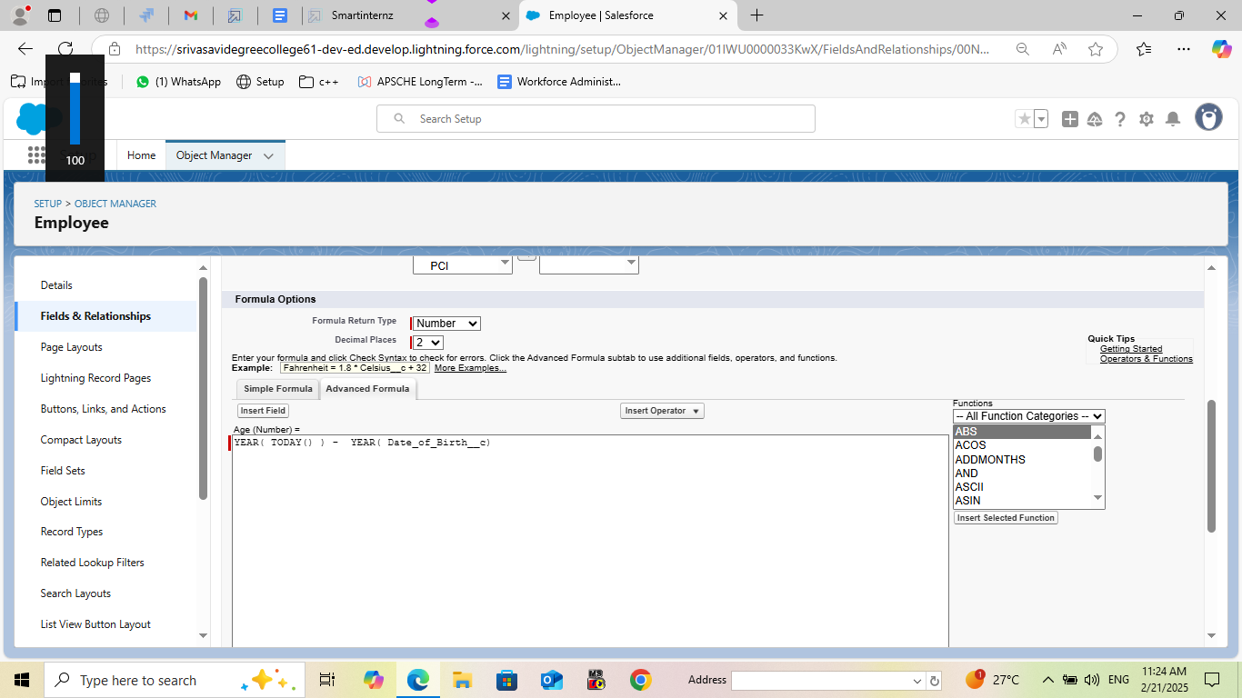

### **ProjectTask Object**

Field name : Finishes in

Data type : Formula

**Formula:** (Project_Task__r.Start_Date__c - Project_Task__r.End_Date__c )

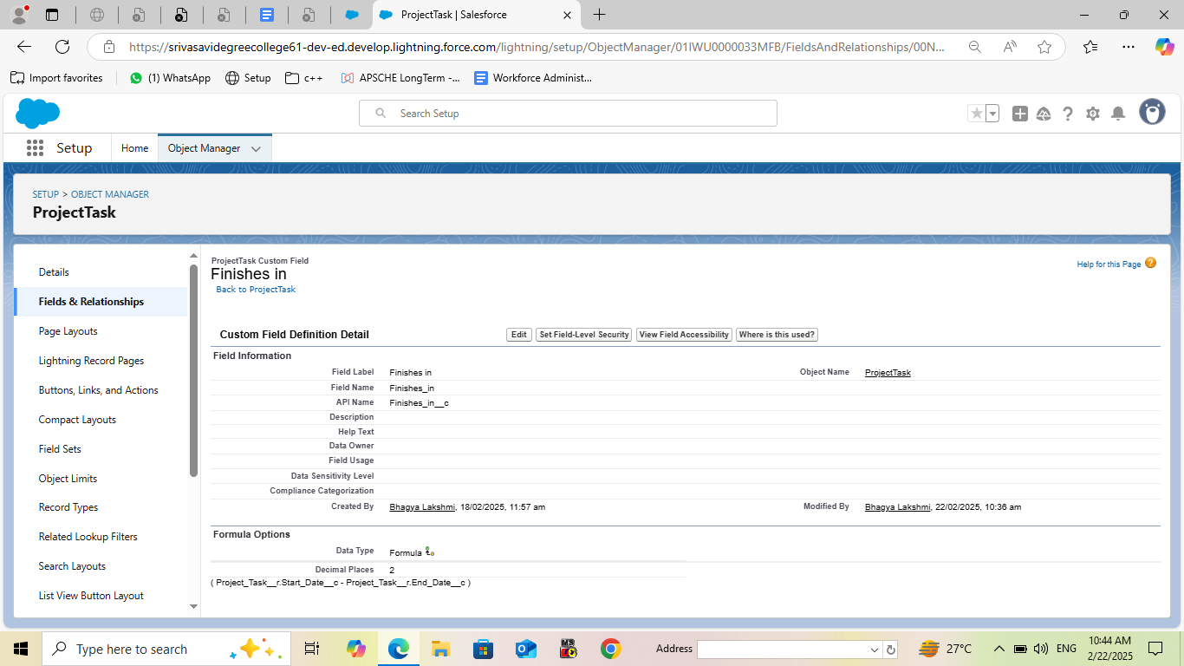

### **Asset**

Field name : Date of issue

Data type : Formula

**Formula:** LastModifiedDate - 7

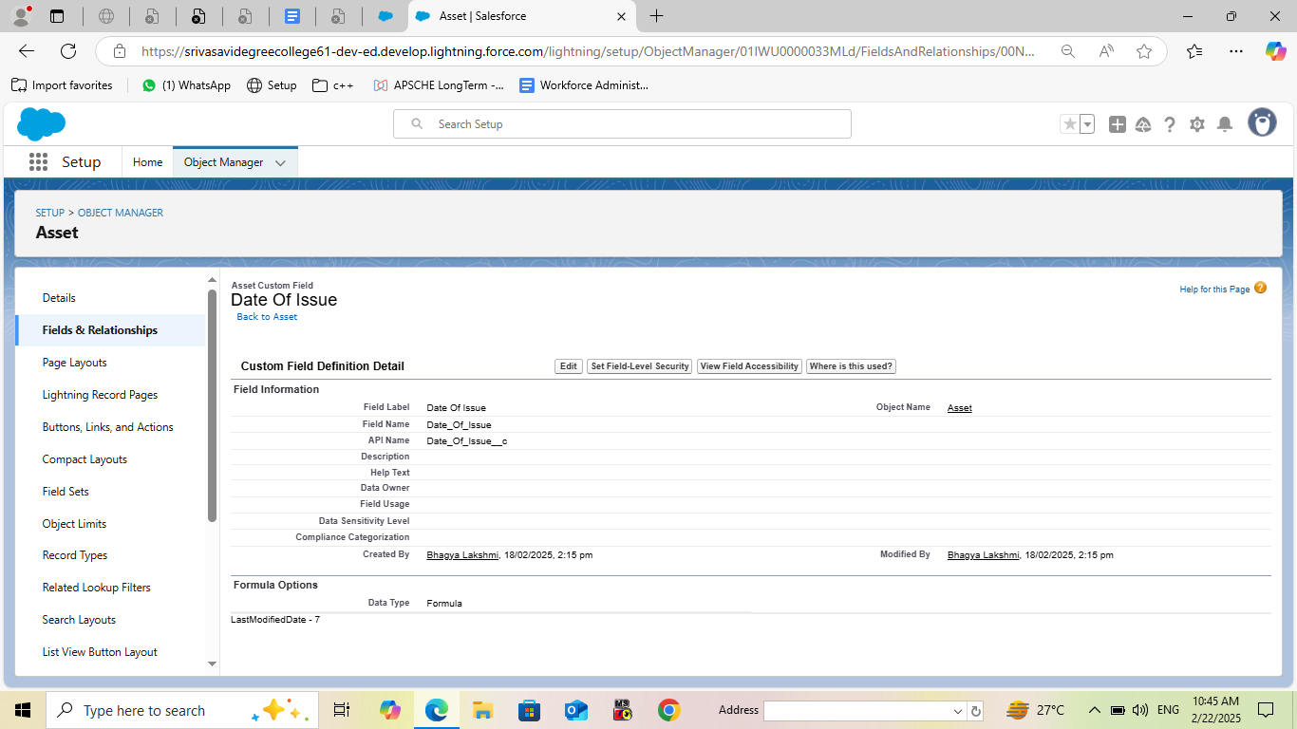

# **Key scenarios addressed by salesforce in the Implementation project :**

* Lead Management: Automate lead assignment, scoring, and routing to ensure timely follow-up.
* Opportunity Management: Streamline opportunity tracking, forecasting, and pipeline management.
* Account Management: Enhance account planning, relationship building, and customer engagement.

Marketing Scenarios

* Campaign Management: Plan, execute, and track marketing campaigns across multiple channels.
* Lead Generation: Automate lead generation, qualification, and nurturing.
* Customer Engagement: Personalize customer interactions and measure engagement metrics.

Service Scenarios

* Case Management: Automate case assignment, routing, and resolution.
* Customer Support: Provide omnichannel support, including phone, email, chat, and social media.
* Field Service Management*

: Optimize field service operations, including scheduling, routing, and inventory management.

Commerce Scenarios

* Order Management: Automate order processing, fulfillment, and shipping.
* Customer Experience: Provide personalized, seamless experiences across online and offline channels.

Analytics Scenarios

* Data Integration: Integrate data from multiple sources, including CRM, ERP, and external data sources.
* Data Visualization: Create interactive dashboards and reports to visualize key performance indicators (KPIs).
* Predictive Analytics: Use machine learning and predictive analytics to forecast sales, customer churn, and other business outcomes.

# **Conclusion** :

In my point of view,the implementation of Salesforce is a complex process

that requires careful planning, execution, and testing. Throughout this project, we have outlined the key steps involved in implementing Salesforce, including requirements gathering, solution design, testing and validation, and deployment.

We have also identified key scenarios addressed by Salesforce in the implementation process, including sales, marketing, service, commerce, analytics, and integration scenarios.

By following the steps outlined in this project and addressing the key scenarios, organizations can ensure a successful Salesforce implementation that meets their business needs and drives user adoption.

## 